

Measures of Variability

Table 2.11: Annual Payouts for Two Different Investment Funds



Measures of Variability

Range Variance

Standard Deviation Coefficient of Variation

|  |  |  |
| --- | --- | --- |
| **Year** | **Fund A ($)** | **Fund B ($)** |
| 1 | 1,100 | 700 |
| 2 | 1,100 | 2,500 |
| 3 | 1,100 | 1,200 |
| 4 | 1,100 | 1,550 |
| 5 | 1,100 | 1,300 |
| 6 | 1,100 | 800 |
| 7 | 1,100 | 300 |
| 8 | 1,100 | 1,600 |
| 9 | 1,100 | 1,500 |
| 10 | 1,100 | 350 |
| 11 | 1,100 | 460 |



Measures of Variability

Table 2.11: Annual Payouts for Two Different Investment Funds (cont.)

|  |  |  |
| --- | --- | --- |
| **Year** | **Fund A ($)** | **Fund B ($)** |
| 12 | 1,100 | 890 |
| 13 | 1,100 | 1,050 |
| 14 | 1,100 | 800 |
| 15 | 1,100 | 1,150 |
| 16 | 1,100 | 1,200 |
| 17 | 1,100 | 1,800 |
| 18 | 1,100 | 100 |
| 19 | 1,100 | 1,750 |
| 20 | 1,100 | 1,000 |
| Mean | 1,100 | 1,100 |

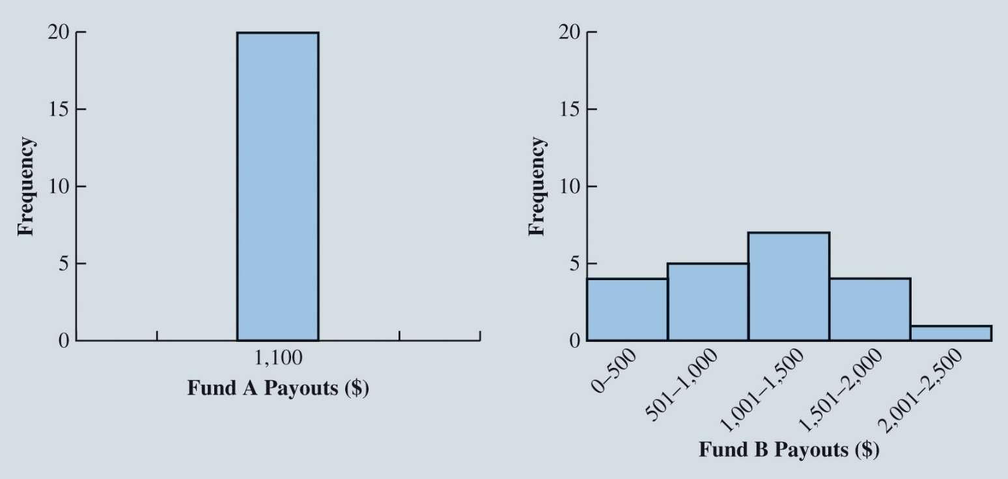

Measures of Variability

Figure 2.18: Histograms for Payouts of Past 20 Years from Fund A and Fund B



Measures of Variability

Range:

◆ The **range** can be found by subtracting the smallest value from the largest value in a data set.

◆ Illustration: Consider the data on home sales in a Cincinnati, Ohio, suburb.

◆ Largest home sales price: $456,250. Range = Largest value – *S*mallest value

◆ Smallest home sales price: $108,000. = $456,250 – $108,000

= $348,250

◆ Drawback: Range is based on only two of the observations and thus is highly influenced by extreme values.

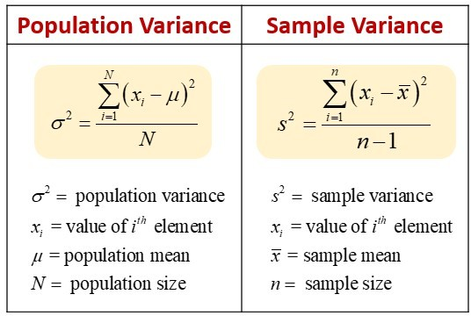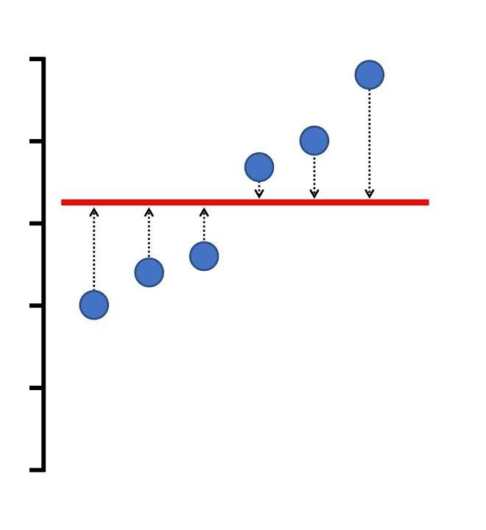

Measures of Variability

◆ Variance:

◆ is a measure of variability that utilizes all the data.

◆ It is based on the deviation about the mean, which is the difference between the value of each observation

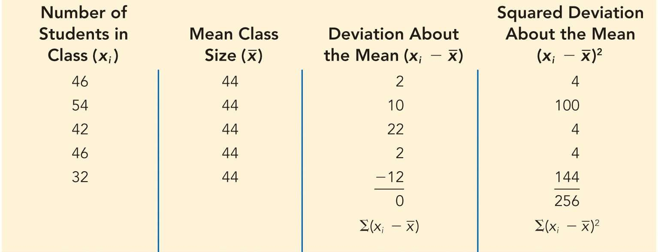

Measures of Variability

Table 2.12: Computation of Deviations and Squared Deviations About the Mean for the Class Size Data

◆ Computation of Sample Variance:

𝑠2 =

Σ 𝑥i − 𝑥 2

𝑛 − 1

= = 64 students 2

256

4

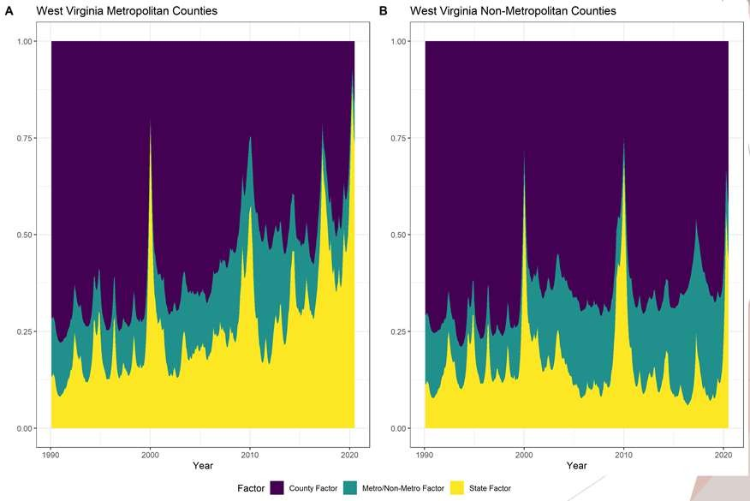

Variation in the Change in Labor Force Participation Rates

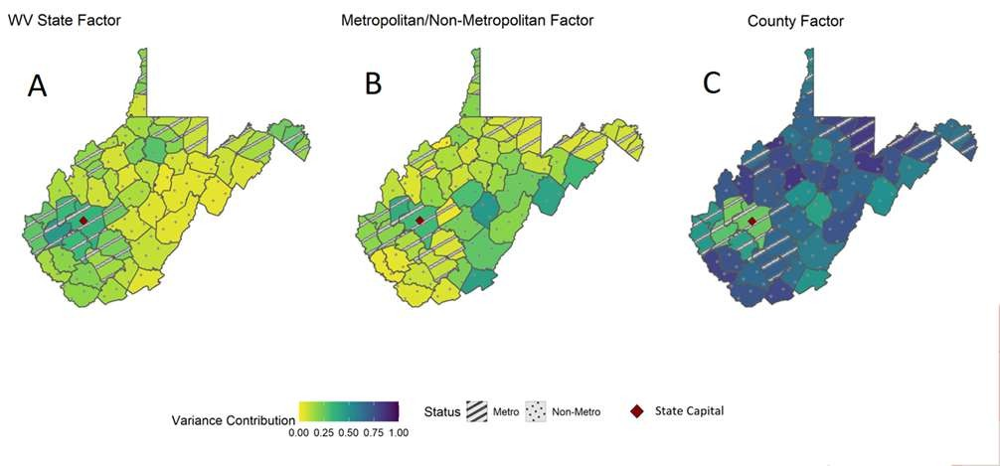

Variation in the Change in Labor Force Participation Rates

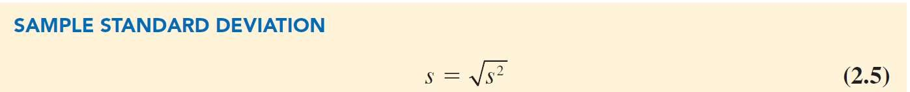

Measures of Variability

◆ **Standard deviation:**

is the positive square root of the variance.

◆ Measured in the same units as the original data.

◆ For population, *σ* = *σ* 2 .

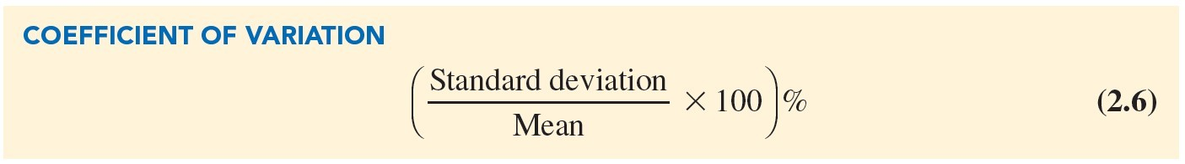

Measures of Variability

The **coefficient of variation**

is a descriptive statistic that indicates how large the standard deviation is relative to the mean.

Expressed as a percentage.



Measures of Variability

Illustration:

◆ Consider the class size data:

46 54 42 46 32

◆ Mean,

*x* = 44.

◆ Coefficient of variation =

( 8 





 44

100 % = 18.2%.



◆ Standard deviation, *s* = 8 (students).

The coefficient of variation tells that the sample standard deviation is 18.2% of the value of the sample mean.



Analyzing Distributions

Percentiles Empirical Rule

Quartiles Identifying Outliers

z-Scores Boxplots

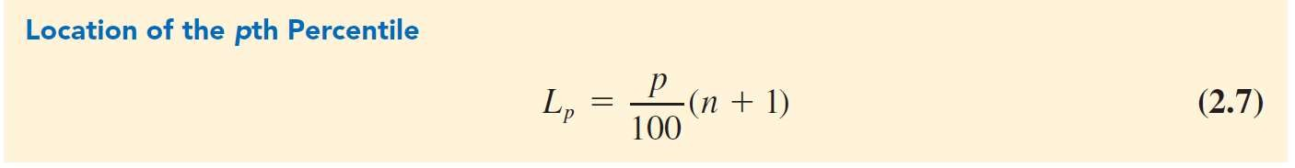

Analyzing Distributions

◆ A **percentile**

◆ is the value of a variable at which a specified (approximate) percentage of observations are below that value.

◆ The *p*th percentile tells us the point in the data where:

◆ Approximately *p* percent of the observations have values less than the *p*th percentile.

◆ Approximately:

(100 – *p*) percent of the observations have values greater than the *p*th percentile.



Analyzing Distributions

Illustration:

◆ To determine the 85th percentile for the home sales data:

◆ Arrange the data in ascending order:

2. Compute

*L* =

85

*p*

100

(*n* + 1) =  (12 + 1) = 11.05.

( 85 

 100 

3. The interpretation of *L*85 = 1 1 .0 5

is that the 85th percentile is 5% of the way

between the value in position 11 and value in position 12.

|  |  |  |  |
| --- | --- | --- | --- |
| 108,000 | 138,000 | 138,000 | 142,000 186,000 199,500 |
| 208,000 | 254,000 | 254,000 | 257,500 298,000 456,250 |



Analyzing Distributions

Illustration (cont.):

◆ To determine the 85th percentile for the home sales data:

◆ The value in the 11th position is 298,000.

◆ The value in the 12th position is 456,250.

◆ $305,912.50 represents the 85th percentile of the home sales data:

85th percentile = 298,000 + 0.05(456,250 – 298,000)

= 298,000 + 0.05(158,250)

= 305,912.50



Analyzing Distributions

**Quartiles:** When the data is divided into four equal parts:

◆ Each part contains approximately 25% of the observations.

◆ Division points are referred to as quartiles.

*Q*1 = first quartile, or 25th percentile.

*Q*2 = second quartile, or 50th percentile (also the median).

*Q*3 = third quartile or 75th percentile.

◆ The difference between the third and first quartiles is often referred to as the **interquartile range**, or IQR.



Analyzing Distributions

◆ The **z-score:**

◆ measures the relative location of a value in the data set.

◆ Helps to determine how far a particular value is from the mean relative to the data set’s standard deviation.

◆ Often called the standardized value.

◆ The z -score can be interpreted as the number of standard deviations

𝑥_𝑖 is from the mean 𝑥 ̅.

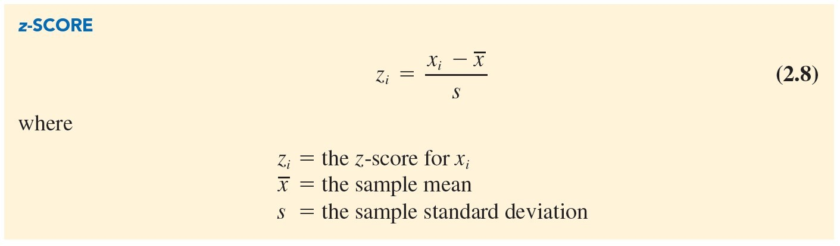

Analyzing Distributions

◆ z-Scores (cont.):

If *x*1 , *x*2 , 😐, *xn* is a sample of *n* observations:

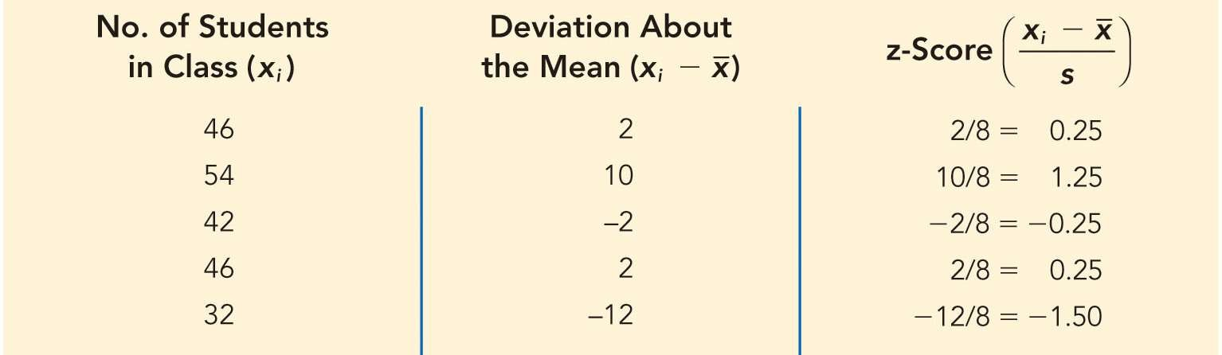

Analyzing Distributions

Table 2.13: *z*-Scores for the Class Size Data

For class size data, *x* = 44 and *s* = 8.

For observations with a value > mean, *z*-score > 0. For observations with a value < mean, *z*-score < 0.



Analyzing Distributions

Empirical Rule:

◆ For data having a bell-shaped distribution:

◆ Approximately 68% of the data values will be within 1 standard deviation.

◆ Approximately 95% of the data values will be within 2 standard deviations.

◆ Almost all the data (99.7%) values will be within 3 standard deviations.

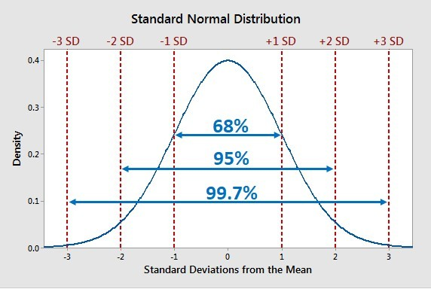

Analyzing Distributions

A Symmetric Bell-Shaped Distribution

◆ The height of adult males in the United States

◆ Mean 69.5 inches and

◆ Standard deviation of 3 inches.

◆ 1 SD -> 68% of U.S. males are between 66.5 and 72.5 in tall

◆ 2 SD -> 95% of U.S. males are between 63.5 and 75.5 in tall

◆ 3 SD -> 99.7% of U.S. males are between 60.5 and 78.5 in tall



Analyzing Distributions

**Outliers**:

Extreme values in a data set.

◆ They can be identified using standardized values (*z*-scores).

◆ Any data value with a *z-*score less than –3 or greater than +3 is an outlier.

◆ Such data values can then be reviewed to determine their accuracy and whether they belong in the data set.



Analyzing Distributions

**Outliers:**

◆ Data value incorrectly recorded;

◆ Correct before further analysis.

◆ Data value incorrectly included

◆ It can be removed.

◆ Unusual data value that has been recorded correctly

◆ The observation should remain.

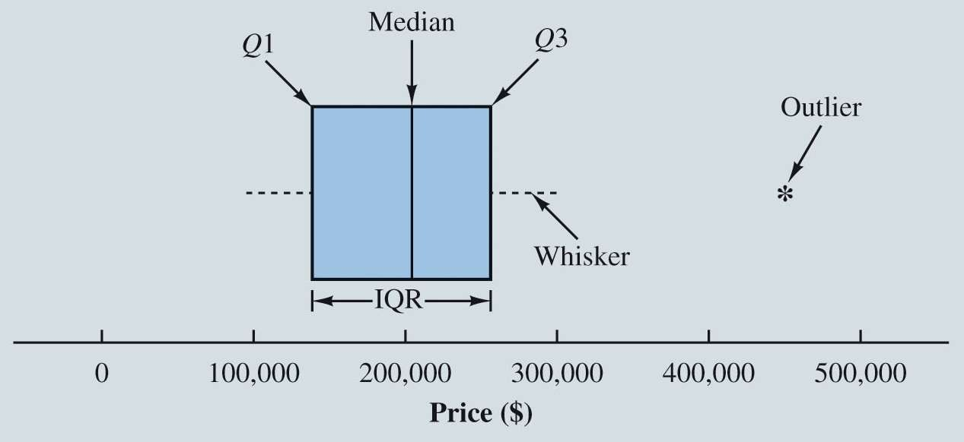

Analyzing Distributions

◆ A **boxplot:**

◆ is a graphical summary of the distribution of data.

◆ Developed from the quartiles for a data set.

Figure 2.22: Boxplot for the Home Sales Data

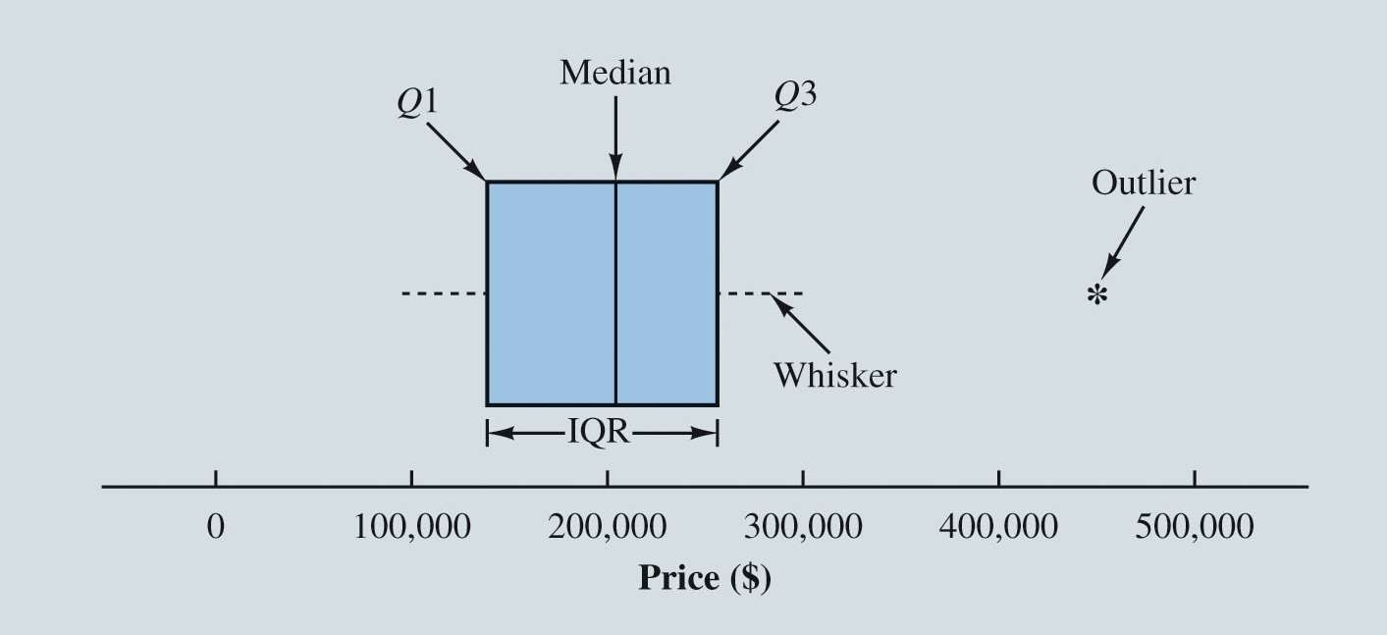

Analyzing Distributions

◆ Steps used to male boxplot:

◆

◆ Draw box with ends located at the first and third quartiles.

◆ E.g. Q1 = 139,000 and Q3 = 256,625.

Draw Whiskers

◆ Dashed lines from the ends of the box to the smallest and largest values inside the limits computed in Step 3.

◆ Values of 108,000 and 298,000.

◆

◆ Draw a line at the median (203,750)

Finally, the location of each outlier is shown with an asterisk

◆ 456,250.

◆ Find Outliers

◆ IQR = Q3 – Q1

◆ Limits = Q1 – 1.5(IQR), Q3 + 1.5(IQR)

◆ IQR = 117,625.

◆ Limits =

◆ 139,000 – 1.5(117,625) = –37,437.5

◆ 256,625 + 1.5(117,625) = 433,062.5

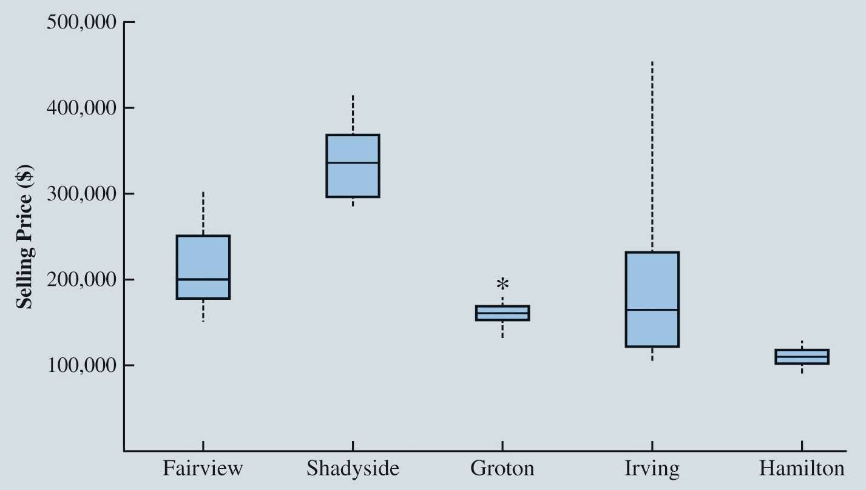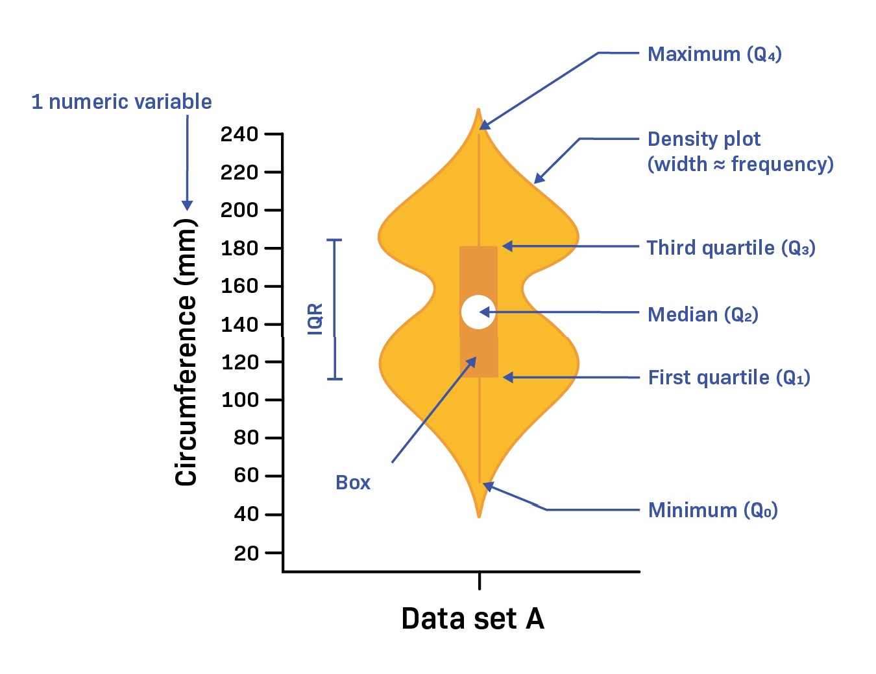

Analyzing Distributions

Figure 2.23: Boxplots Comparing Home Sale Prices in Different Communities

**What do you observe about the differences in Home Prices for different communities?**

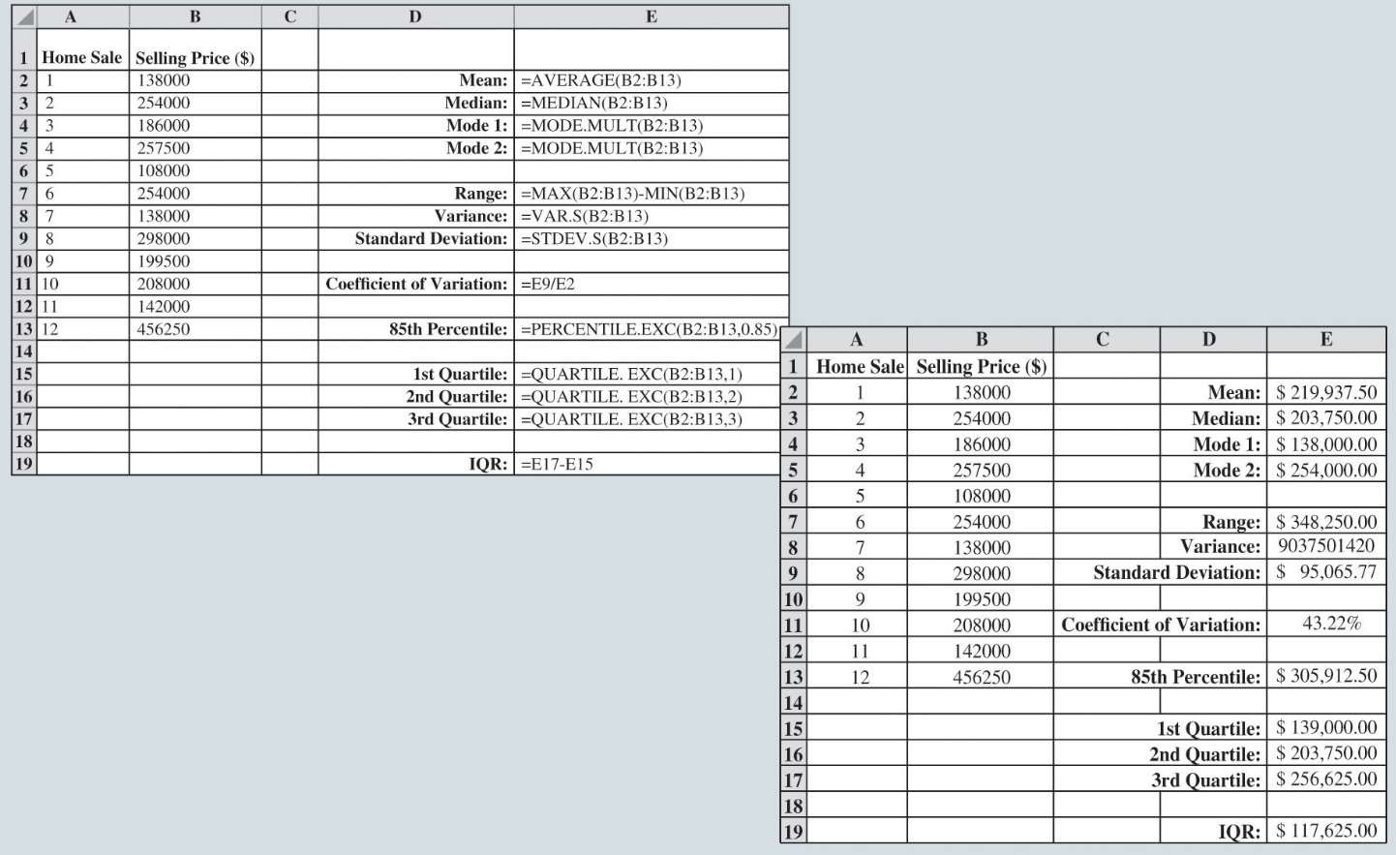

Measures of Variability

Figure 2.19: Calculating Variability Measures for the Home Sales Data in Excel

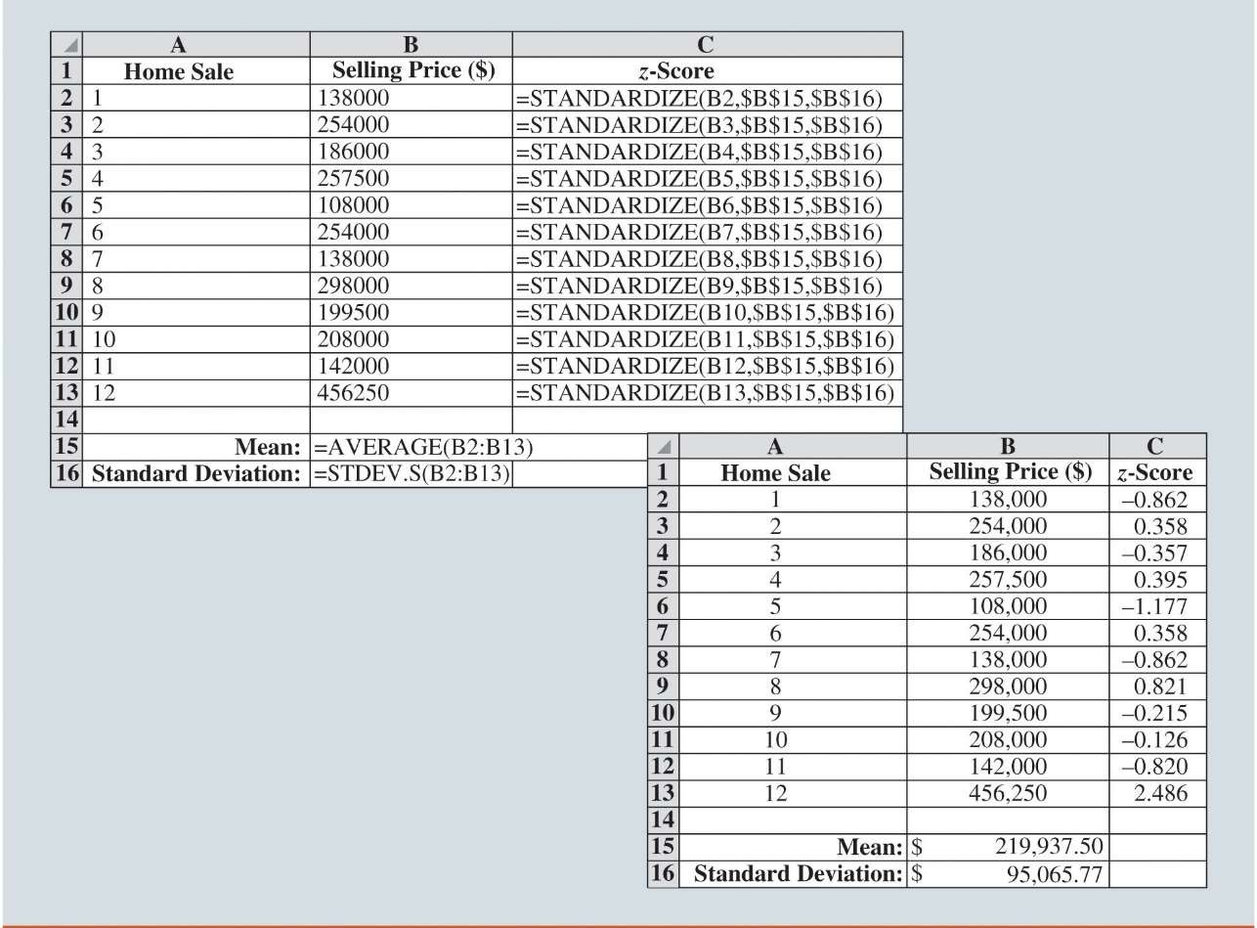

Analyzing Distributions

Figure 2.20: Calculating *z*-Scores for the Home Sales Data in Excel

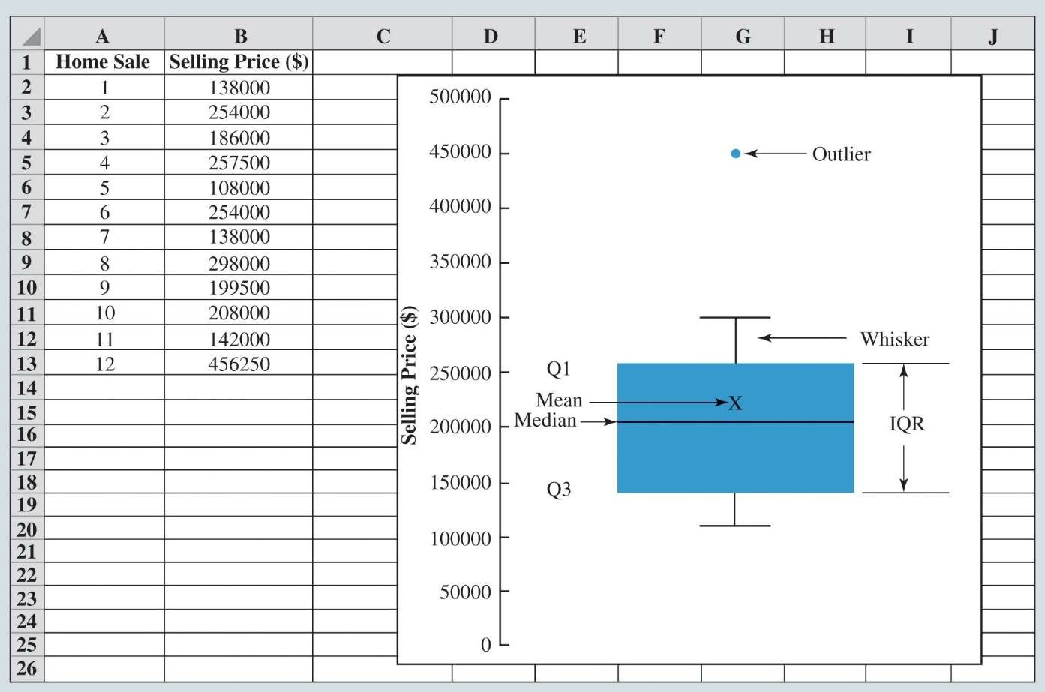

Analyzing Distributions

Figure 2.24: Boxplot Created in Excel for Home Sales Data

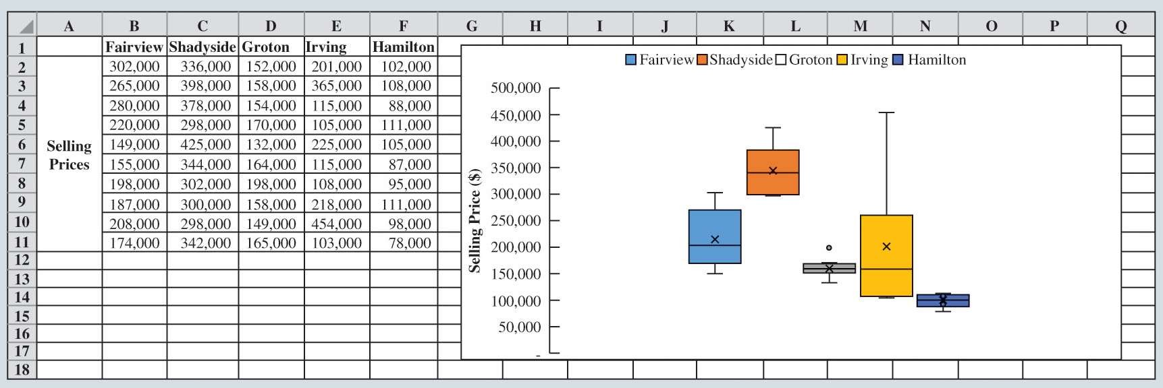

Analyzing Distributions

Figure 2.25: Boxplots for Multiple Variables Created in Excel